feel the difference in
GRAVITY

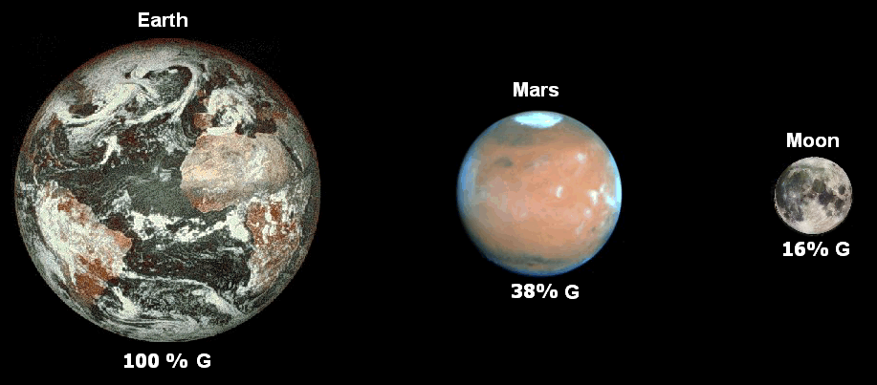

pick up 2 bricks at a time
one in each hand
FEEL the DIFFERENCE

The 10 lb. one shows normal EARTH gravity.

The sand-colored faux brick weighs 3.8 lbs.
On MARS things are only 38% as heavy.

The gray-colored one weighs 1.6 lbs.
On the MOON things are only 16% as heavy

courtesy of the Moon Society St. Louis Outpost
http://www.moonsociety.org/chapters/stlouis
made by Peter Kokh email: kokhmmm@aol.com
make your own set - http://www.nsschapters.org/hub/gravitybricks_howto.htm

