prepared for Moon Madness Night 2009
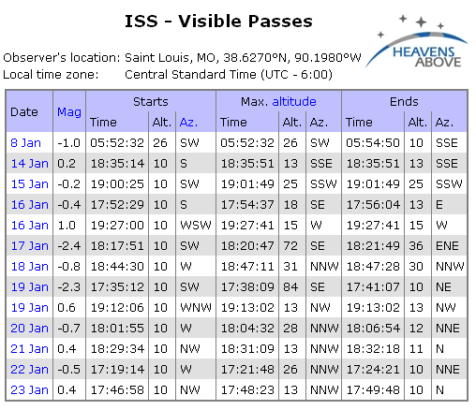

http://www.heavens-above.com/

"select from map" and at the bottom of the page type in (note: altitude is in meters)

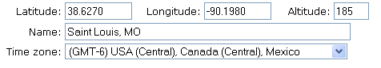
"Submit" and under "Satellites" choose "ISS"

info courtesy of http://www.moonsociety.org/chapters/stlouis/

